 | MINISTRY OF UKRAINE ON AFFAIRS OF  FAMILY, YOUTH AND SPORTS  Sports committee of Ukraine  KYIV CITY STATE ADMINISTRATION  WORLD DANCE & DANCE SPORT COUNSIL  INTERNATIONAL DANCESPORT ASSOCIATION  UKRAINIAN DANCESPORT ASSOCIATION  UKRAINIAN DANCE BOARD  Ukrainian council of ballroom dancing  DANCESPORT CLUB “SPORT DANCE” | 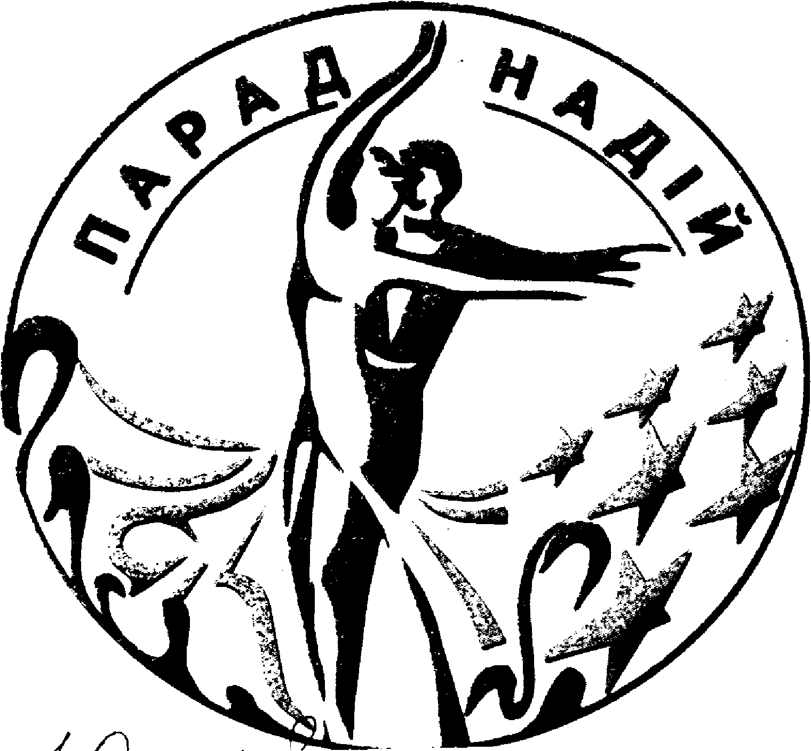

«Parad Nadiy – 2006»
Title: XVI -th International DanceSport Competitions «Parad Nadiy – 2006»
Date: 04 – 05 March 2006
Place: Sport Palace, 1 Sportyvna Square, Kyiv, Ukraine

Group | Categories | 04 March 2006 |  |  | 05 March 2006
Group | Categories | 10.00 | 14.00 | 18.30 | 10.00 | 14.00 | 18.30
1 | IDSA World Latin Championship Adult |  |  |  |  |  | La
2 | IDSA World Latin Championship Under 21 |  |  | La
3 | IDSA World Latin Championship Under 19 |  | La
4 | IDSA World Latin Championship Under 16 |  |  |  |  |  | La
5 | Foxtrot Championship Open to the World |  |  | Foxtrot
6 | Foxtrot Cup Open Adult |  |  |  | St
7 | Foxtrot Cup Open Under 21 |  |  |  |  | St
8 | Foxtrot Cup Open Under 19 |  |  | St
9 | Foxtrot Cup Open Under 16 |  | St
10 | Foxtrot Cup Open Juniors 1 |  |  | La |  |  | St
11 | Foxtrot Cup Open Juveniles 2 | La |  |  | St
12 | Foxtrot Cup Juveniles 1 Open | St |  |  |  | La
13 | Juveniles 1 “E” |  |  |  | 6 dances
14 | Juveniles 2 “E” |  | 6 dances
15 | Juniors 1 “E” | 6 dances
16 | Juniors 1 “D” | St |  |  | La
17 | Juniors 2 “D” | La |  |  | St
18 | Ukrainian Cup Juniors 1 under 14 |  | La |  |  | St
19 | Ukrainian Cup Youth 1 under 19 |  |  |  |  | La
20 | Ukrainian Professional Championship |  |  |  |  |  | La
21 | Ukrainian Professional Championship |  |  |  |  |  | La Show
Judges: Samuel Stopford, England; Jerry Abrate, Italy; Sergey Ryupin, Russia; Stanislav Popov, Russia; Walter Wat – Hong Kong; Harm Jan Schadenberg - Netherlands; Rene Barsi – France; Trilisky, Anatoly.
Chairman - Donnie Burns MBE, Scotland
Dress: WD&DSC Rules must be applied
Starting fee: Per couple for one program: Adult, Under 21,Under 19, Under 16, Juniors 1 -25 Є (equivalent 150 grn); Juveniles 2, Juveniles 1 – 18Є (eq. 110 grn); Foxtrot Chаmpionship – 13 Є (eq. 80 grn); Classification: Juveniles 1”Е”, Juveniles 2 “E”, Juniors 1”E”, Juniors 1 “D”, Juniors 2”D” – 16 Є (eq. 100 grn)
Registration: According to certificate about birth or passport.
Participation for all dance couples in IDSA World Championship Latin is open.
Prize money for IDSA World Championship Latin:
Adult – places: 1st-3000$, 2nd-2000$, 3rd -1000$, 4th - 900$, 5th -800$, 6th -700$,
7th- 600$, 8th- 500$, 9th - 400$, 10th -300$, 11th-200$, 12th-100$.
Under 21 – places: 1st-800$, 2nd-600$, 3rd-400$, 4th-300$, 5th-200$, 6th-100$.
Under 19 – places: 1st-800$, 2nd-600$, 3rd-400$, 4th-300$, 5th-200$, 6th-100$.
Under 16 – places: 1st-600$, 2nd-500$, 3rd-400$, 4th-300$, 5th-200$, 6th-100$.
Entry tickets: - Є 5-10
Entry: Please, send your entry no later than 25 February, 2006 to:
ORGANIZER  Mrs. Valentyna Fedorchuk  Rad. Ukrainy 30, app. 56, Kyiv, Ukraine-04215  Phone/fax: +38 044 463 01 70, 463 51 06  E-mail: sportdans@ukr.net Sportdans@rambler.ru | Ukrainian Dance Sport Association  Dr. Svyatoslav T. Vlokh, UDSA President  7/13, Saksaganskoho str., Kyiv, Ukraine-01033  Phone/fax: +38 044 289 02 51  E-mail: udsa@gu.kiev.ua
Entry for professional couples: Please, send your entry no later than 25 February, 2006 to:
Ukrainian Dance Board – member of World Dance and Dance Sport Council,
Mrs. Irena Bous’, UDB President Phone/fax: +38 032 298 63 38, e-mail: info@ukrdanceboard.com

