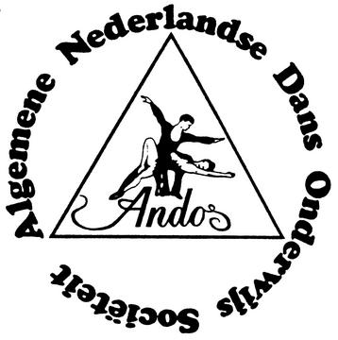PLANNED DANCECOMPETITIONS 2007

2007

date name of competition Place Organisor Classification

January 20 Veluwe Cup Putten ANDOS/ DS Kriekaart B
February 4 7th Northsea Cup Wijk aan Zee ANDOS/DS Cor Oosterhoorn AA
February 18 26th MIDWINTERDANSEN Hemrik ANDOS/Jacob Meijer AA
March 4 Piet Boekhoudcup Austerlitz ANDOS/Nico Jansen C
March 25 3rd Austerlitzcup Austerlitz ANDOS/Nico Jansen A
April 9 5th Westbrabantcup Ossendrecht ANDOS/DS V.d. Broek A
April 29 28th Noord Nederlandse Danskamp. Heerenveen ANDOS/Jacob Meijer A
Mai 6 Dutch Championships open Austerlitz ANDOS AA
June 2 WORLDCUP Wierden ANDOS/N. Jansen AA
October 28 2nd Utrecht Championships Austerlitz ANDOS/Nico Jansen B
November 25 10th European Championships Hemrik EADO-ANDOS/Jacob Meijer AA
December 16 18th Frisian Open Leer (D) SDF/DS Schumann-Spekker A

Tournament classification: C = very small competition B = small competition A = normal competition AA=High ranked competition
All competitions mentioned are open to all IDU members.
More information can be obtained by e-mail: andos@dsjm.nl
There are classes for various ages, as well as various levels.
All competitors dance prelimary rounds to obtain correct classification.

