 | MINISTRY OF UKRAINE ON AFFAIRS OF FAMILY, YOUTH AND SPORTS  INTERNATIONAL DANCESPORT FEDERATION  ALL-UKRAINIAN DANCESPORT FEDERATION  DANCE SPORT CLUB “HARMONY” | 
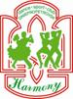 | 11–13 December  VIII International Open Dance Sport Competition  STANISLAV SHKLYAR’S CUP – 2009 | 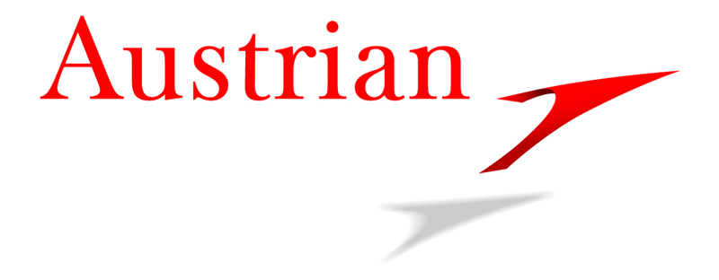

Title: IDSF INTERNATIONAL Open Latin, IDSF INTERNATIONAL Open Standard.
Place: Ukraine, Kharkov, CP “Kharkov Sport Palace”(M. Zhukova avenue, 2). /status on the 17.11.09/

Categories: | Friday, 11 December |  |  | Saturday, 12 December |  |  | Sunday, 13 December
Categories: | 9³⁰ | 14⁰⁰ | 19⁰⁰ | 9³⁰ | 13⁰⁰ | 18³⁰ | 9³⁰ | 13⁰⁰ | 18³⁰
Juniors 1+2 beginners | W, Q, Ch, J
Ladies Juveniles 1+2 | S,Cha,R
Ladies Juniors 1+2 | S,Cha,R
Juveniles 1 “E” | 6 D
Juveniles 2 “E” | 6 D
Juniors 1+2 “E” |  | 6 D
Juveniles 1+2 “D” |  | 8 D
Juniors 1 “C” | ST | LAT
Juniors 2 “C” |  | ST | LAT
Juniors 1 “D” | ST | LAT
Juniors 2 “D” | ST+LAT
Youth + Adults “D” |  |  |  | LAT |  |  | ST
Youth + Adults “C” |  | LAT | ST
IDSF International Open St |  |  |  |  | ST | ¹/₄ ST
IDSF International Open Lat |  |  |  |  |  |  |  | LAT | ¹/₄ LAT
Senior Open |  |  |  |  | ST |  |  | LAT
Youth Open |  |  |  |  | LAT | ½ LAT |  | ST | ½ ST
Juniors 2 Open |  |  |  |  | ST |  |  | LAT
Juniors 2 Open 10 dance |  |  | 10 D
Juniors 1 Open |  |  |  | LAT |  |  | ST
Juveniles 2 Open |  |  |  | 4 ST |  |  | 4 LAT
Juveniles 1 Open |  |  |  | 4 ST |  |  | 4 LAT
Чемпионат Украины  Ювеналы 1 |  |  |  |  | ST
Чемпионат Украины  Ювеналы 2 |  |  |  |  |  |  |  | LAT
Чемпионат Украины  Юниоры 1 10 танцев |  |  | 10 D
Взрослые |  |  | Кубок Украины  10 D | Кубок Украины  ST |  |  | Отборочные LAT

Judges: 13 International Judges from different countries-members of IDSF and Ukrainian Judges
Dress: IDSF Rules must be applied
Registration deadline: November 27, 2009.
Prize money: Adult: 1st place – 500 €, 2nd place –300 €, 3rd place – 200 €, 4-6st places – 100 €
Hotel: Per person per night from 25 € to 70 €. Application for hotel must be sent till December 5,
Only by e-mail: harmony@optima.com.ua (Please, mark- hotel reservation)
or by fax: +38(056)776-73-76
Applications sent after December 5 will not be considered.
Online registration only on www.shklyarcup.dp.ua. Регистрация только на сайте www. shklyarcup.dp.ua

Dance Sport Club “HARMONY”  Mr. Oleg Petrovs’kyy, DSC “Harmony” President  12, V.Dubinin str., Dniepropetrovsk, 49050, Ukraine  tel: +38 0562 36 64 65 fax: +38 056 776 73 76  E-mail: harmony@optima.com.ua  Web-Site: www.dance.dp.ua | “All Ukrainian Dance Sport Federation  E-mail: Office_AUDSF@mail.ru  Web-Site: www.adsf.com.ua

