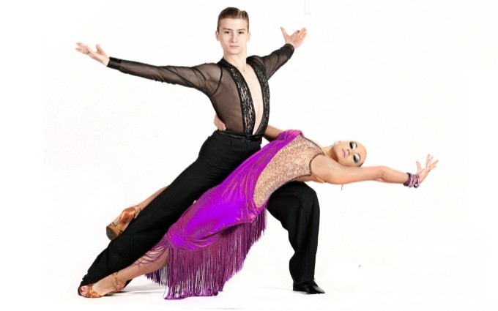


Title: TATRY CUP – POLAND OPEN’ 2016
Date: 02 April 2016
Place: Poronin - Poland
Address: Piłsudskiego 34, 34 – 520 Poronin – Poland
Website: www.facebook.com/Pro-AmDanceInfo or www.podhaletanczy.pl

Tentative Competition Schedule

No | CATEGORIES | 10:00- Start of competitions | 12:00 - Start of competitions | 15:00- Start of competitions | 19:00 - Start of competitions
1 | Senior over 35 |  | C,S,R,P,J |  | W,T,V,F,Q
2 | Senior over 45 |  |  | C,S,R,P,J | W,T,V,F,Q
3 | Junior (Up to 16) | C,S,R,,J | W,T,V,,Q
4 | Youth (Up 18) | LA | ST
5 | Adult Open (19 and older) |  |  | ST | LA
6 | Pro Am Single Dance | W,T,V,F,Q  C,S,R,P,J
7 | Pro Am 2 Dance Challenge |  | W,T,C,R
8 | Pro Am 3 Dance Challenge |  |  | W,T,Q,C,S,R
9 | Pro Am Scholarship |  |  |  | ST/LA

Adjudicators: WDC International adjudicators
Starting fee: Per couple for one program – 30 € (Junior, Youth, Adult & Senior)
Rules: WDC Rules must be applied!
Registration: This competition is open in all age groups. Registration in all age groups is made according to the date of birth in passports.

Hotel & Visa invitations: Reservation by: boleslawbara@wp.pl - email
Entry: Please send your entry no later than – 21st March 2016 , email: boleslawbara@wp.pl

Official competition Venue:

Hotel Bania**** Thermal & Ski

www.hotelbania.pl

