 | MINISTRY OF UKRAINE ON AFFAIRS OF  FAMILY, YOUTH AND SPORTS  Sports committee of Ukraine  KYIV CITY STATE ADMINISTRATION  WORLD DANCE COUNSIL  INTERNATIONAL DANCESPORT ASSOCIATION  UKRAINIAN DANCESPORT ASSOCIATION  Council of Presidents of Dancesport of Ukraine  DANCESPORT CLUB “SPORT DANCE” | 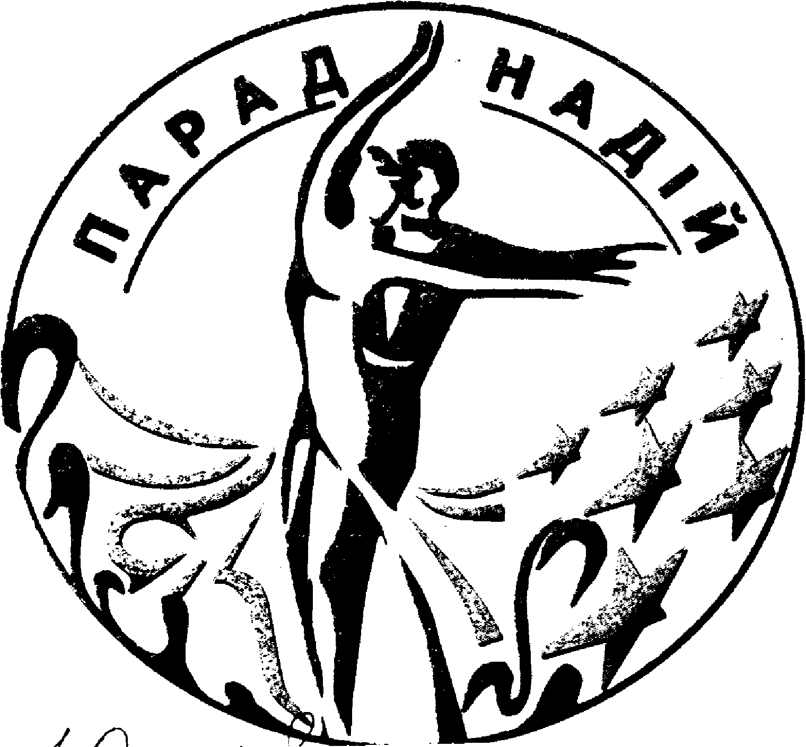

«Parad Nadiy – 2007»
Title: XVII -th International DanceSport Competitions «Parad Nadiy – 2007»
Date: 03 – 04 March 2007
Place: Sport Palace, 1 Sportyvna Square, Kyiv, Ukraine

Group | Categories | 03 March 2007 |  |  | 04 March 2007
Group | Categories | 10.00 | 14.00 | 18.30 | 10.00 | 14.00 | 18.30
1 | IDSA World Championships Latin Senior |  |  |  |  | La
2 | IDSA World Championships Latin Adult |  |  |  |  |  | La
3 | IDSA World Championships Latin Under 21 |  |  | La
4 | IDSA World Championships Latin Under 19 |  |  |  |  |  | La
5 | IDSA World Championships Latin Under 16 |  |  | La
6 | IDSA World Championships Latin Under 14 |  |  |  |  |  | La
7 | Foxtrot Championship Open to the World |  |  | Foxtrot
8 | Foxtrot Cup Open Adult |  |  |  |  | St
9 | Foxtrot Cup Open Under 21 |  | St
10 | Foxtrot Cup Open Under 19 |  |  | St
11 | Foxtrot Cup Open Under 16 |  | St
12 | Foxtrot Cup Open Under 14 |  |  | St
13 | Foxtrot Cup Open Juveniles 2 |  | La |  |  | St
14 | Foxtrot Cup Open Juveniles 1 | St |  |  |  | La
15 | Juveniles 1 “H” |  | W Q Ch J
16 | Juveniles 2 “H” |  |  |  | W Q Ch J
17 | Juveniles 2 “E” | St, La
18 | Juniors 1 “E” |  |  |  | St, La
19 | Juniors 2 “E” |  | La |  | St
20 | Juniors 1 “D” | St |  |  | La
21 | Juniors 2 “D” | La |  |  | St
22 | Ukrainian Championship Formation |  | St |  |  | La
23 | Ukrainian Professional Championship |  |  | La |  |  | St
Judges: Registered WD&DSC
Dress: WD&DSC Rules must be applied
Starting fee: Per couple for one program: IDSA World Championships Latin Senior; Adult; Under 21,Under 19, Under 16, Under 14 -30 Є; Foxtrot Cup – 30 Є; Foxtrot Championship – 20 Є; Classification – 20 Є; Ukrainian Championships Formation – 10 Є/ per person.
Entry tickets: - Є 5-10.
Registration: According to certificate about birth or passport.
Participation for all dance couples in IDSA World Latin Championships is open.
Prize money for IDSA World Latin Championships:
Adult – places: 1st-3000$, 2nd-2000$, 3rd -1000$, 4th - 900$, 5th -800$, 6th -700$,
7th- 600$, 8th- 500$, 9th - 400$, 10th -300$, 11th-200$, 12th-100$;
Senior – places: 1st-800$, 2nd-600$, 3rd-400$, 4th-300$, 5th-200$, 6th-100$;
Under 21 – places: 1st-800$, 2nd-600$, 3rd-400$, 4th-300$, 5th-200$, 6th-100$;
Under 19 – places: 1st-800$, 2nd-600$, 3rd-400$, 4th-300$, 5th-200$, 6th-100$;
Under 16 – places: 1st-600$, 2nd-500$, 3rd-400$, 4th-300$, 5th-200$, 6th-100$;
Under 14 – places: 1st-600$, 2nd-500$, 3rd-400$, 4th-300$, 5th-200$, 6th-100$;
Hotel: Hotel reservation via Internet: www.all-hotels.com.ua
Entry: Please, send your entry no later than 24 February, 2007 to:
ORGANIZER  Mrs. Valentyna Fedorchuk  V. Porika 7a, app. 140, Kyiv, Ukraine-04208  Phone/fax: +38 044 463 51 06  E-mail: sportdans@ukr.net sportdans@rambler.ru | Ukrainian Dance Sport Association  Dr. Svyatoslav T. Vlokh, UDSA President  7/13, Saksaganskoho str., Kyiv, Ukraine-01033  Phone/fax: +38 044 289 02 51  E-mail: udsa@gu.kiev.ua

