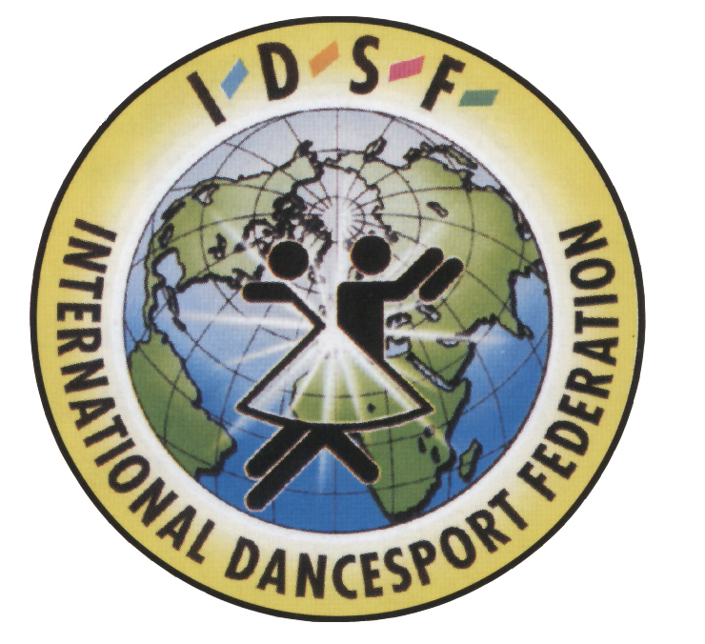 | International Dance Sport Federation (IDSF)  All Ukrainian Union «Sport and Dance» (AUPOSD)  Dance Sport Federation «Dynamo-Ukraine»  DSF “Dynamo-Lux ”,Kherson | 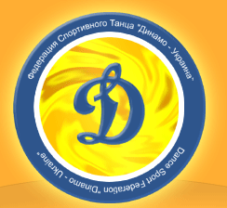
17-18 May 2008 Traditional International Open Competitions

«Skadovsk-2008»

AUPOSD Open competitions in all categories

IDSF Open Adults St & La

Skadovsk, The Palace of Culture, Communarov str.,66
Categories | 17 May |  |  |  | 18 May
Categories | First Floor |  |  |  | First Floor
Categories | 1 part 11:00 |  | 2 part 15:30 |  | 1 part 11:00 |  | 2 part 15:30
Junior 1beginner |  |  | W,Q,Ch,J
Juveniles 1Е | S,Ch,J |  |  |  | 6 d. St+La |  | W,T,Q
Juveniles 2Е | W,T,Q |  |  |  | 6 d. St+La |  | S,Ch,J
Ladies 1 |  |  |  |  | S,Ch
Ladies 2 |  |  |  |  | S,Ch,Rb
Juniors 1Е | W,T,Q |  | 6 d. St+La |  | S,Ch,J
Juniors 2Е | S,Ch,J |  | 6 d. St+La |  | W,T,Q
Juveniles 1D |  |  | 4d.St |  |  |  | 4d.La
Juveniles 2D |  |  | 4d.La |  |  |  | 4d.St
Juniors 1D | 4d.St |  |  |  |  |  | 4d.La
Juniors 2D | 4d.La |  | W,T,Q |  |  |  | 4d.St
Youth «E+D» | W,T,Q |  | S,Ch,J |  |  |  | 6 d. St+La
Categories | Second Floor |  |  |  | Second Floor
Categories | 1 part  11:00 | 2 part 15:30 |  | 3 part  19:00 | 1 part  11:00 | 2 part  15:30 |  | 3 part  19:00
Babies 5-7 years |  |  |  | W,Ch
Children 1 beginner | W,Q,Ch,J
Children 2 beginner |  |  |  |  | W,Q,Ch,J
Juveniles 1 | 4d. St |  |  |  | 4d. La
Juveniles 2 | 4d.La |  |  |  | 4d. St
Juniors 1 |  | St |  |  |  | La
Juniors 2 |  | La |  |  |  | St
Youth 16- 18 |  |  |  | La |  |  |  | St
Youth 16- 21 |  | St |  |  |  | La
Adults |  |  |  | St  IDSF |  |  |  | La  IDSF
Seniors |  |  |  | S,Ch,R,J |  |  |  | W,T,V,Q
Judges: Members of AUPOSD and IDSF judges.
Dress: IDSF rules must be applied
Prize money in IDSF category St & Lat: 1000$,800$,600$,300$,200$,200$
Starting fee (per person for one program):Babies, Ladies,beginners-30 uah.,
Е class St,La.-30 uah., Е class St+La-40 uah., Д class.-40 uah., Juveniles, Juniors-50 uah. ,
Seniors-50 auh, Youth-60 uah., Adults -70 uah.
Entry tickets- 35 uah. For all day.
Registration deadline 01.05.2008.
e-mail: style3@tlc.kherson.ua office AUPOSD and DSF “Dynamo-Ukraine”:
Fax (+380552) 454310 , (fax) +380-62-3872260, tel.+380-50-3283083
Mob. tel. +38050-521 81 31, +38050- 396 18 49 е-mail: auposd@mail.ru
www.ukrsportdance.com

