World Dance Poland 
Polish Dance Sport Foundation

Thursday, December 8, 2011

MIKOLAJKI DANCE FESTIVAL – 2012

Date: 17-18.03.2012
Place: Hotel «Gołębiewski», Mikołajki, Poland www.golebiewski.pl

We are inviting you to visit one of the most charming places on Masuria.
Hotel Gołębiewski in Mikołajki**** is delightfully situated in very heart of the Land of great lakes, on crossing the most beautiful tourist trails of Poland. Natural richness - forests and reserves - are enrapturing arriving here Guests and they allow for full relaxing. The wealth of offered attractions, the nice service and the modern conference back will provide you both wonderful rest.
Comfortable numbers, aqua park, the beauty and health center, children's room, bar, restaurant "buffet", restaurant "menu", horse-racing club, tennis courts, golf club, night club, billiards, a bowling alley.

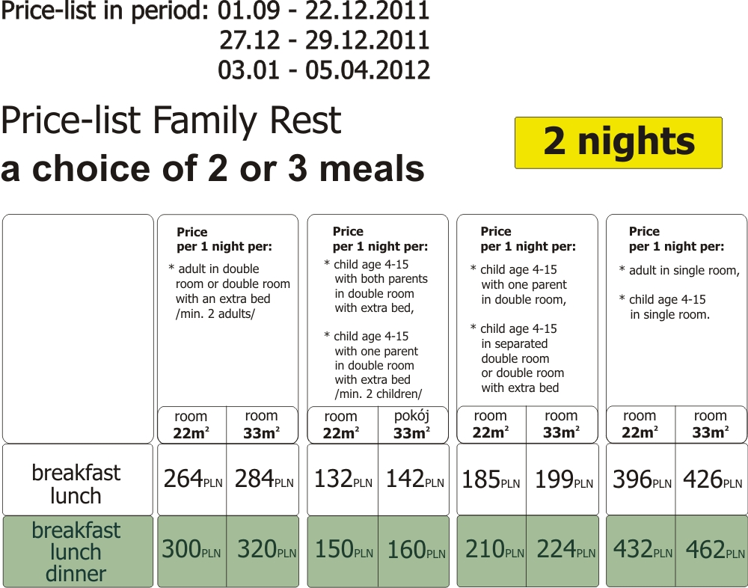

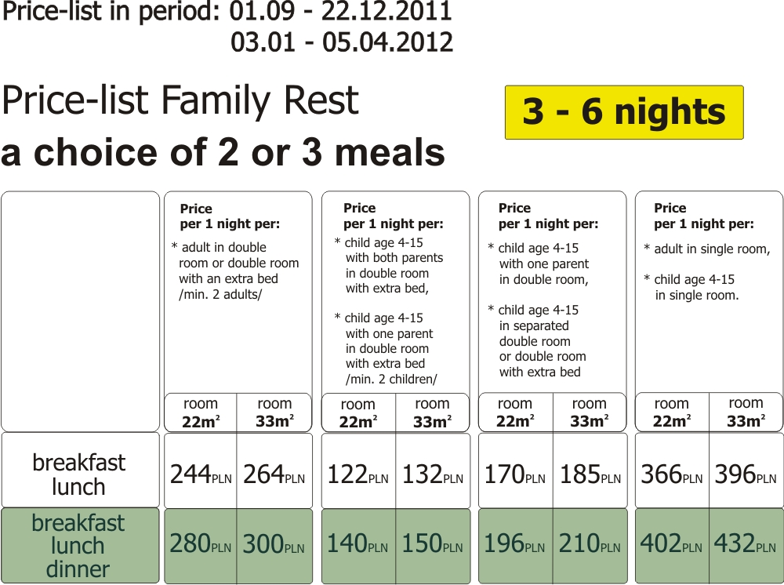 1 EUR = 4,5 PLN

Reservation and payment of accommodation through organizers of Festival is obligatory up to 30.01.2012.

Account No:
Fundacja Rozwoju Tańca Polskiego
Chopina 49 B – 14; 71-450 Szczecin – Poland

SWIFT KOD – CITIPLPX ; Account in EUR: PL77 1030 0019 0109 7860 1006 3504

Till 31.01.2012 through organizers of Festival it is necessary to pay the deposit for residing.

HOTEL: Reservation of hotel «Gołębiewski» strictly till 30.01.2012 on e-mail: sienkiewicz@autograf.pl

Organizers:
Polish Dance Sport Foundation
Marek Sienkiewicz, PDSF President
E-mail: sienkiewicz@autograf.pl
Tel: +48914541955, Mob.: +48601771391

