 | MINISTRY OF UKRAINE ON AFFAIRS OF  FAMILY, YOUTH AND SPORTS  Sports committee of Ukraine  KYIV CITY STATE ADMINISTRATION  WORLD DANCE COUNSIL  INTERNATIONAL DANCESPORT ASSOCIATION  UKRAINIAN DANCESPORT ASSOCIATION  DANCESPORT CLUB “SPORT DANCE” | 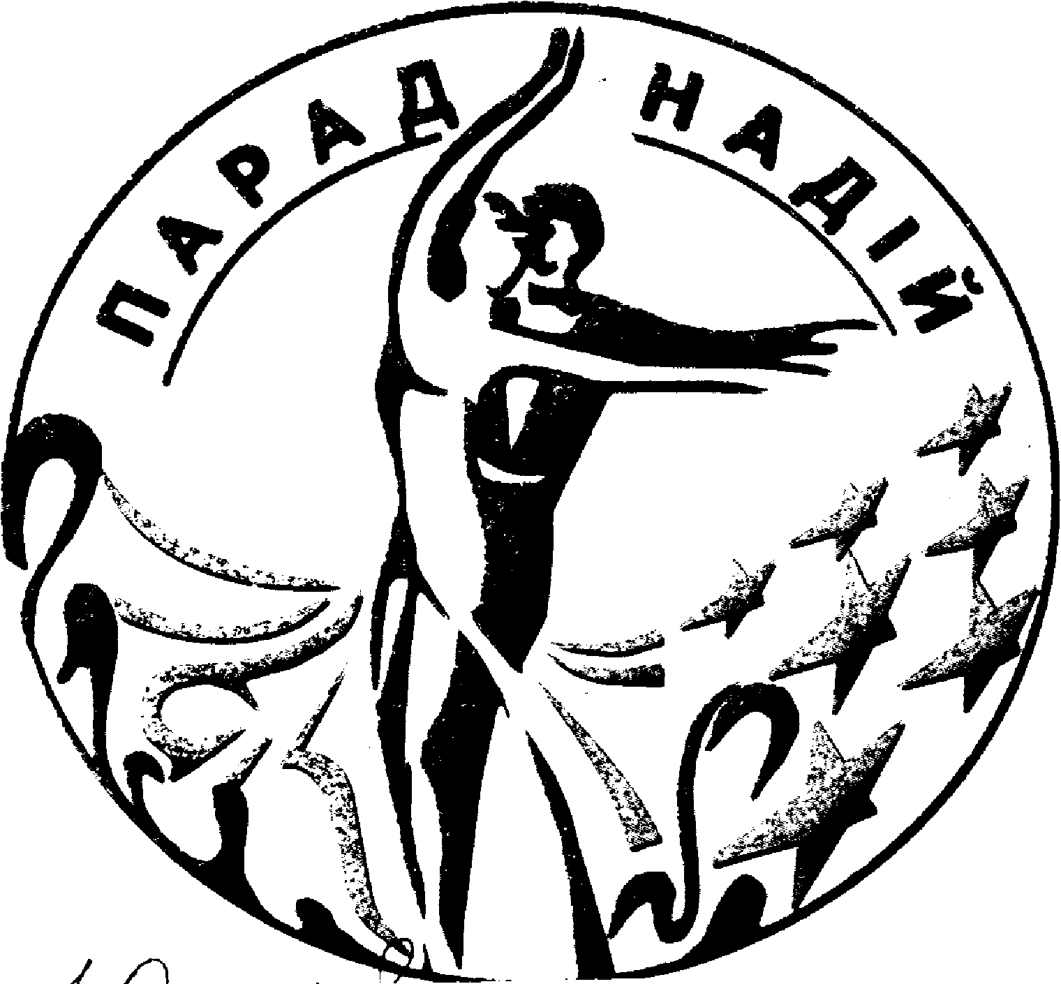

«Parad Nadiy – 2008»
Title: XVIII -th International DanceSport Competitions «Parad Nadiy – 2008»
Date: 01 – 02 March 2008
Place: Sport Palace, 1 Sportyvna Square, Kyiv, Ukraine

Group | Categories | 01 March 2008 |  |  | 02 March 2008
Group | Categories | 10.00 | 14.00 | 18.30 | 10.00 | 14.00 | 18.30
1 | WDC World Professional Classic  Show dance |  |  | St
2 | Foxtrot Cup Open Adult |  |  | St |  |  | La
3 | Foxtrot Cup Open Under 21 |  |  | La |  |  | St
4 | Foxtrot Cup Open Under 19 |  | St |  |  |  | La
5 | Foxtrot Cup Open Under 16 |  |  | La |  | St
6 | Foxtrot Cup Open Under 14 |  |  | St |  |  | La
7 | Foxtrot Cup Open Juveniles 2 |  | La |  | St
8 | Foxtrot Cup Open Juveniles 1 |  |  |  | St,La
9 | Foxtrot Championship Open |  |  | Foxtrot
10 | Rumba Championship Open |  |  |  |  |  | Rumba
11 | Foxtrot Cup Open Juveniles 2  (beginners)  “H”begin | W,Q  Ch. J
12 | Foxtrot Cup Open Juveniles 2 “E” | St,La
13 | Foxtrot Cup Open Juveniles 2 “D” | St |  |  | La
14 | Foxtrot Cup Open Juniors 1  (beginners) | W,Q  Ch. J
15 | Foxtrot Cup Open Juniors 1 “E” |  |  |  | St,La
16 | Foxtrot Cup Open Juniors 1 “D” | St |  |  | La
17 | Foxtrot Cup Open Juniors 2 “D” |  | La |  | St
18 | Foxtrot Cup Open Juniors 2 “C” |  | La |  |  | St
19 | Foxtrot Cup Open Baby (5-7 years) |  |  | w, ch ,j,
20 | Ukrainian Championship Formation |  |  |  |  | La
21 | Ukrainian Cup Senior |  | St |  |  | La
22 | Ukrainian Cup Under 21 |  |  |  |  | La
Judges: Registered WDC
Dress: WDC Rules must be applied
Starting fee: Per couple for one program: Foxtrot Cup Open : Adult; Under 21,Under 19, Under 16, Under 14 ,Juveniles 1, Juveniles 2 --30 Є; Foxtrot Championship, Rumba Championship – 20 Є; Classification – 20 Є; Ukrainian Championships Formation – 10 Є/ per person, Ukrainian Cup ( Senior, Under 21) -25 Є. Baby -15Є
Entry tickets: - Є 5-10.
Registration: According to certificate about birth or passport
Prize money for : Adults ( latin), Under 21 ( latin)
Adult – places: 1st-300$, 2nd-250$, 3rd -200$, 4th - 150$, 5th -100$, 6th -100$,
Under 21 – places: 1st-300$, 2nd-250$, 3rd-200$, 4th-150$, 5th-100$, 6th-100$;
ALL Finalists rewarding with medals, sweets and beautiful prizes
Hotel: Hotel reservation via Internet: www.all-hotels.com.ua
Entry: Please, send your entry no later than 25 February, 2008 to:
ORGANIZER  Mrs. Valentyna Fedorchuk  V. Porika 7a, app. 140, Kyiv, Ukraine-04208  Phone/fax: +38 044 463 51 06  E-mail: sportdans@ukr.net sportdans@rambler.ru | Ukrainian Dance Sport Association  Dr. Svyatoslav T. Vlokh, UDSA President  7/13, Saksaganskoho str., Kyiv, Ukraine-01033  Phone/fax: +38 044 289 02 51  E-mail: udsa@gu.kiev.ua

